Customer Churn Data Analysis (Excel based Analytics Project)
Introduction:
Customer churn is the loss of customers or subscribers over a period of time indicating the loss of trust and dissatisfaction towards the company.it is one of the critical challenges faced by the subscription based or the service-based companies. Retaining customers is more effective and cost effective in the long-term success of a business. Hence customer churn analysis helps in providing the root cause and improve the customer relationship.
Project Overview:
In this project the customer churn analysis was done using the Microsoft excel. The analysis was mainly focused on the behavioural and demographic attributes. Based on the data driven insights, a risk scoring model was created that help to categorise the customers based on the risk levels for further future action. The model successfully helps to identify the high-risk customers displaying its practical applicability for making business decisions.
Objective:
The objective of this project was to analyse the customer churn behaviour and develop the risk segmentation framework that identifies the customers that are most likely to churn.
Primary objectives:
- To analyse the behavioural and demographic factors influencing the customer churn.
- To identify the significant churn drivers using exploratory data analysis.
- To design weighted risk scoring framework to segment the customers into high, medium and low risk categories.
- To validate the effectiveness of the model using the pivot-based churn analysis.
- To generate the actionable insights for retention strategy.

Data profile:
- Age
- Tenure
- Usage Frequency
- Payment Delay
- Support Calls
- Contract Type
- Monthly Revenue
- Churn Status (0 = Retained, 1 = Churned)
Target Variable is churn.

Data preparation and cleaning:
- Checking for missing values, blanks.
- Checking for duplicates.
- Creating calculated fields such as risk score and risk level.
- Formatting the data into the tables.

Exploratory data analysis:
Pivot tables were used to analyse the overall churn rate across the different variables.
Key findings from the dataset:
- Overall churn rate: The overall churn rate was found to be 47.37%, which shows nearly half of the customers’ dissatisfaction and withdrawal from the service.
- Payment delay: The customers who delayed their payment for more than 21 days have relatively more churn rate.
- Tenure: Customers with more than 24 months of tenure are most likely to churn, especially the one who have delayed payments. A clear structural shift in churn behaviour was observed at the 24-month mark, where churn rates increased sharply from approximately 28–30% to above 55%, indicating a possible customer lifecycle effect, where long-term customers reassess service value and are more likely to switch providers after extended usage.
Usage frequency: Less usage also correlates with the withdrawal of the customers.
- Support calls: The customers with 5 or more support calls showed dissatisfaction- related churn trends.
- Age, Gender, Subscription type: While the gender and subscription type has no significant effect on the churn rate, the customers with age 48 or more are more likely to churn.

Risk scoring model:
A rule-based scoring system was created by assigning different weights to defined categories.
Variable | Condition | Score
Payment Delay | ≥16 | 3
Tenure | ≥24 | 3
Usage Frequency | ≤5 | 2
Support Calls | ≥4 | 2
Age | ≥48 | 1
Monthly Contract | Yes | 1

Segmentation of customers based on total risk score:
0-3 – low risk
4-6 - medium risk
7 or more – high risk

Model Validation:
The model was validated using the pivot analysis.
High risk segment:
- Segment size=48.59% of the total customers.
- Churn rate= 80% (80% of high-risk customers churned)
- Contribution to the total churn = 82.07% (82% of all the churn came from the high-risk group)

Key performance indicators (KPIs)
- Total Customers: 64374
- Total Churned Customers: 30493
- Overall Churn Rate: 47.37%
- High Risk Segment Size: 48.59%
- High Risk Churn Rate: 80%
- High Risk Contribution to Total Churn: 82.07%
Although the overall churn rate stands at 47.37%, the High-Risk segment exhibits a dramatically elevated churn rate of 80% and accounts for 82.07% of total churn.
This demonstrates that the segmentation model effectively isolates churn-prone customers and provides a clear opportunity for targeted retention strategies focused on the High-Risk segment.

Visual Insights:

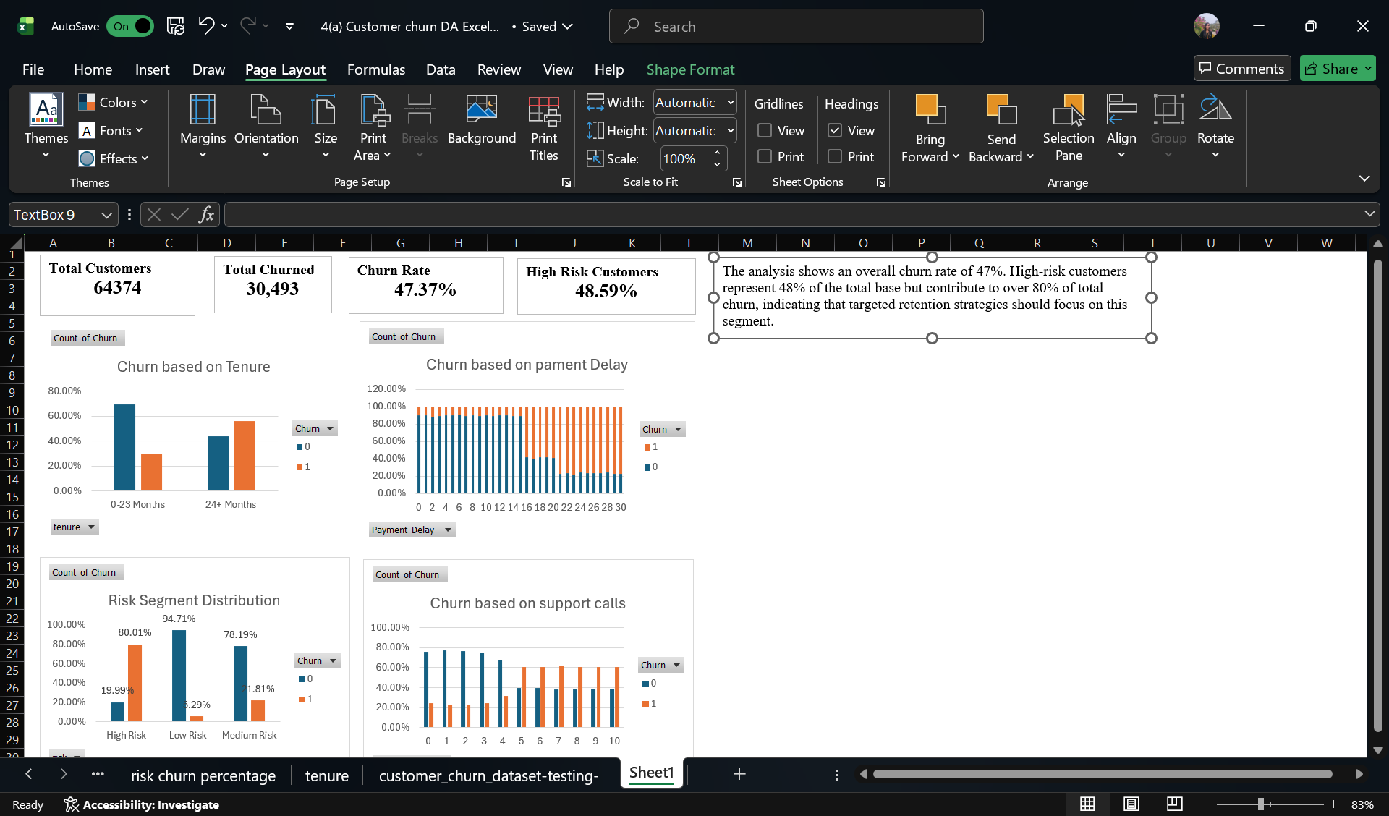

Business Insights and Recommendations:
- Prioritize Retention Campaigns for High-Risk Customers.
- Identify customers with high churn probability using risk scoring models.
- Offer personalized incentives (discounts, flexible payment plans, exclusive offers).
- Flag customers with frequent late payments or increasing delay trends.
- Set automated alerts for delays beyond a defined threshold (e.g., 7–14 days)
- Trigger early engagement (reminder calls, payment assistance options).
- Identify customers with repeated service complaints.
- Conduct root-cause analysis of recurring issues.
- Segment customers based on tenure duration and offer loyalty rewards (cashbacks, exclusive features, milestone benefits.
Conclusion:
This analysis is aimed to evaluate customer churn behaviour and develop a structured risk segmentation framework to identify churn-prone customers. It was Identified that a high overall churn rate of 47.37% across 64,374 customers, highlighting a significant retention concern.
Risk-based segmentation revealed that 48.59% of customers fall into the High-Risk category, with an 80% churn rate within this segment. Notably, 82.07% of total churn originates from the High-Risk group, demonstrating strong concentration of churn behaviour.
While the model is rule-based and not predictive in nature, it demonstrates strong segmentation capability and practical applicability for strategic retention planning.
These results validate the effectiveness of the segmentation model in isolating churn-prone customers. By prioritizing targeted retention strategies toward the High-Risk segment, the organization can significantly reduce overall churn and can improve their customer retention.

